**Khulna University of Engineering and Technology**

Department of Computer Science and Engineering



SYSTEM DEVELOPMENT PROJECT

CSE 3200

**“Fingerprint Based Biometric Attendance System”**

By

**Projapoti Roy**

Roll: 1607041

&

**Sharia Wasika Aditi**

Roll: 1607109

**Supervisor:**

**Prottoy Saha**

Lecturer

Department of Computer Science and Engineering

Khulna University of Engineering and Technology

___________________

Supervisor’s Signature

**Contents**

**Abstract:**

In this project, the design and development of Biometric Attendance System based on fingerprint is presented. The project consists of two process namely ‘enrollment’ & ‘attendance’. The method of enrolling fingers and recording attendance is done with the help of fingerprint module. Using SD Card module the attendance details of a student are saved in a file**.**Rather than recording the attendance in writing or queueing in front of class which is time killing, attendance can be recorded easily and shortly with the help of this system. Also it prevents proxy of students which has become a bad trend nowadays.

**Motivation:**

In every educational institutions, the authority keeps track of the attendance of all students. But the attendance system is poor. The system can easily be manipulated. For example, a teacher has to pass a printed sheet to record the attendance of the students. A student needs to fill the sheet with his/her signature. In this case, some of the students can imitate their friends' signatures even though they are absent. To avoid this issue, many teachers are to call out the students' name or roll during the class time. But this approach is very time consuming.

To solve these issues, we have planned to introduce a system that is ‘**Fingerprint based Biometric Attendance System’** which will be helpful for our education system.

**Objectives:**

* Introducing a new system to the educational era.
* To design fingerprint based biometric attendance system.
* To enroll fingers of the students for the system.
* To take attendance of the students.
* To calculate average attendance of a student from the attendance sheet at the end of the semester.

**Introduction:**

In every educational institutions,attendance is compulsory for every student. Specially, most of the universities in Bangladesh have a procedure not to allow their students to attend examination if their attendance is less than 60 percentange.

With the existence of our proposed system,it would be helpful for authority to record students’ attendance. Our system consists of two process – enrolment and attendance. First of all, all the students have to enroll their fingers. The fingerprint of a student is captured and its unique features called minutiae points extracted using crossing number method and stored in internal memory of fingerprint module with the student’s identity as a template. During attendance, the fingerprint of the student is captured again and the extracted features compared with the template in the internal memory of the fingerprint module to determine a match before attendance is made. If fingerprints are not matched, the system will show a message ‘Finger not found’.

For further purpose,the attendance details are stored in a file with the help of SD card module.

We all know that fingerprints are one of the main forms in biometric field which are used to identify the individuals and their uniqueness. Two persons’ fingerprints are not similar. So, the students will never give attendance for their friends.

From manually marking the attendance in attendance registers to using biometric systems,the overall system has been improved significantly.

**Equipments:**

1. Arduino Mega

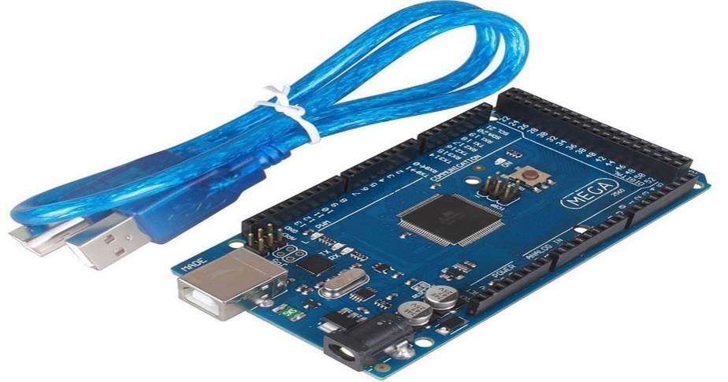

Fig 1: Arduino Mega

1. Fingerprint Module

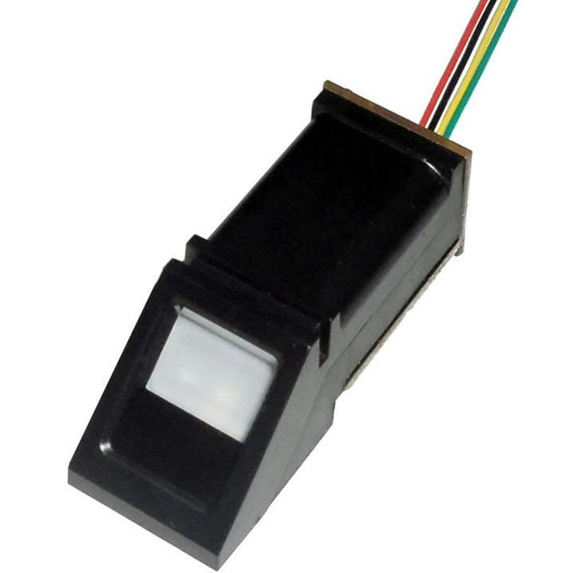

Fig 2: R307 Fingerprint Module

1. Real Time Clock(RTC) Module

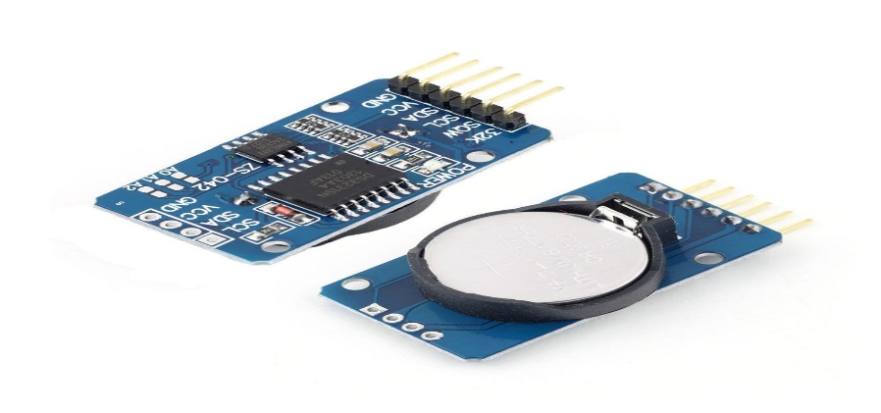

Fig 3: DS3231 RTC Module

1. SD Card Module

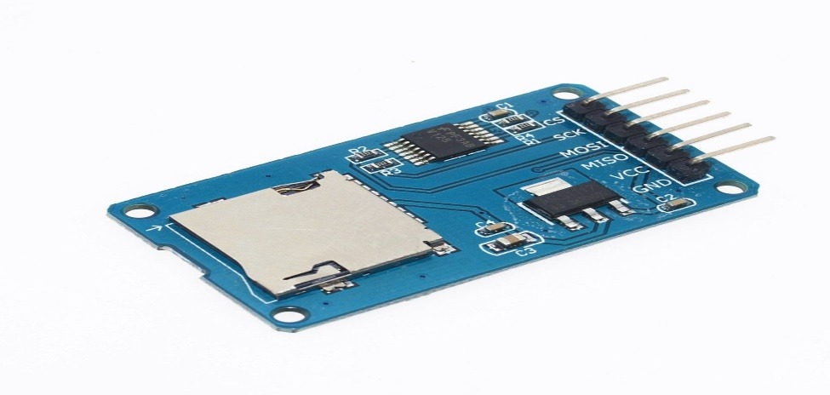

Fig 4: SD Card Module

1. Keypad



Fig 5: 4*4 Keypad

1. LCD Display

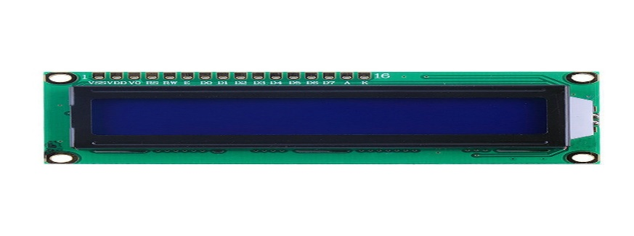

Fig 5: 16*2 LCD Display

1. Potentiometer 8. Card Reader & MicroSD Card
2. Bread Board 10. Connecting wires

**Project Description:**

This proposed system introduces a new automatic attendance management system which integrates fingerprint authentication into the process of attendance management for the students. It consists of 2 processes –

i)Enrolment ii)Attendance

We have used Fingerprint module to identify a true person by taking his/her finger input in the system. Here we have used 4*4 keypad for setting class date & time and also handling enrolment & attendance processes. RTC module is used for obtaining the current time & date for the fingerprint reader. It can record the exact time when a student attends the class.

In the enrolment stage, all the students have to register their fingers against their id numbers. So when the students want to enroll their fingers, they have to press key ‘B’ and then lcd asks for the ID where they want to store their fingers. With the help of key ‘C’ & ‘D’ they can select their IDs and then have to press ‘#’ to proceed with selected ID. Then LCD shows some messages like place finger,remove finger,place same finger again. Maintaining all these steps, fingerprint of the student is captured and its unique features called minutiae points are extracted and is converted into a template and stored by the selected ID into the internal memory of fingerprint module i.e. fingerprint database. All the students have to be enrolled before giving attendance.

Now the students want to give attendance, they have to press key ‘A’. Then LCD asks for placing finger on the fingerprint module. Then the fingerprint is captured again and the extracted features compared with the template in the database to determine a match before attendance is made. If the fingerprint is not matched lcd shows a message ‘Finger not found’ and if matched, the system will check if matching (student check in time) is made within the first 15 minutes of the class time. If so, the student will be considered as present otherwise it will be a late attendance for him/her. We have used key ‘*’ for back operation.

We have used SD card module as interface between SD card and the microcontroller Arduino. It consists of an SD card which is the type of storage used to store the student’s record. Attendance details will be saved in a file (.txt) of the SD card for further purpose. Then we extracted the data from .txt file to an excel sheet. From the excel sheet, we have calculated the percentage of total attendance of every student. The following figure describes our proposed system.

Finger Not Found

This will save time wasted on calling out

names and it gives a fool-proof method of attendance marking

This will save time wasted on calling out

names and it gives a fool-proof method of attendance marking

No

Process of scanning & searching fingerprint

Fingerprint is matched?

Setup Class Date & Time

Place Finger

Here, s is student check in time & t equals to class starts time + 15 minutes

Yes

s <= t?

Display Date & Time

Press A for Attendance

No

Yes

Present

Late Consideration

Press B for Enrolling new finger

Display Student’s ID on the LCD with a message

Press C or D to select ID & then press # to proceed with selected ID

Finger placed & process scanning started

Stored Finger against ID

Save present ID’s details in SD card

No

Yes

Back?

Press *

Fig 6: Flowchart for our proposed Fingerprint Based Biometric Attendance System

**Block Diagram:**

SD Card Module

Fingerprint Module (R307)

(R307

Computer

Arduino Mega

LCD Display

Keypad

RTC Module

(DS3231)

Fig 7: Block Diagram of Biometric Attendance System

**Methodology:**

Figure 7 shows the block diagram of the proposed system. The design combines the microcontroller with the Fingerprint Module, display, and communication interfaces. This integration accelerates development while maintaining design flexibility and simplifies testing. Fingerprints are a form of biometric identification which is unique and does not change in one’s entire lifetime. A fingerprint is made of a series of ridges and valleys on the surface of the finger. The uniqueness of a fingerprint is determined by the pattern of ridges and valleys as well as the minutiae points. Minutiae points are local ridge characteristics that occur when a ridge splits apart or a ridge ends. The following processes are happened in the internal of fingerprint module -

1. Image Acquisition
2. Image Enhancement
3. Edge Detection
4. Extraction of Miniature Points and Matching

Fingerprint **Image Acquisition** is considered to be the most critical step in an automated fingerprint authentication system, as it determines the final fingerprint image quality which has a drastic effect in the overall system. Automated fingerprint verification systems use live scan digital images of fingerprints from a fingerprint sensor. These images are used in image enhancement stage.

In general, due to skin conditions(e.g. dry,wet,bruise etc), sensor noise, incorrect finger pressure and inherent low quality fingers, many fingerprints acquired are of low quality that lead to problems in minutiae extraction. **Image Enhancement** improves the clarity of ridge and valley structures in the fingerprint images. Histogram equalization method is used for image enhancement.

The purpose of **edge detection** is to significantly reduce the amount of data found in a fingerprint image and leave only the most important information. Edge detection works by finding points on an image where the gray scale of value changes greatly between pixels. They are many operators used for detecting the edges. The operators are Prewitt, Laplacian, Sobels, Robertson operators. The prewitt operator is one of the best edge detecting operators and it detects two types of edge – horizontal edges & vertical edges. The edges have to be detected in order to match the input image with already saved image. Edges are calculated by using difference between corresponding pixels intensities of an image. All the masks (vertical & horizontal) that are used for edge detection are also known as derivative masks. For vertical mask, it calculates the difference of right and left pixel values around that edge. For horizontal mask, it calculates the difference of above and below pixel intensities of the particular edge. Thus increasing the sudden change of intensities and making the edge more visible.

Most of the minutiae extraction techniques trace the fingerprint skeleton to find different types of minutiae points. After the extraction of edges, the points are marked in it. These points which are detected after edge detection are known as **miniature points**. The miniature points that are extracted are compared with already stored images. In order to find the matching process the correlation factor and the Euclidean distance has to be found out. Based on the tolerance value the matching results can be found out. The described stages are done in enrolment process.

Then comes authentication process. It the most repeated process and it is done each time a student wants to make use of fingerprint module. When he/she places his/her finger on scanner surface, the fingerprint will be processed by the scanner. The fingerprint pattern that has been obtained would be compared against the stored enrolment template that is already stored in fingerprint database . When the fingerprint pattern passes the comparison process, it shows a message and allows student’s access.

All the attendance details will be saved in a file (.txt file) . Then we have extracted the file into excel sheet and from the excel sheet, we have calculated the attendance percentage of each students and other so. We have maintained following rules for marking attendance.

1. Student should scan his/her finger correctly on the fingerprint sensor module. If fingerprint is not putted correctly on reader, it could lead errors. There are two reasons for error - Failure to enroll rate (FTE) and Failure to capture (FTC) rate of biometric device. FTC rate depends on functionality of the system and FTE occur due to poor quality inputs .
2. Students should mark their attendance within 15 minutes of start time of class. For example, if a class starts on 11.30am, attendance will be marked

(present) before 11.45 am. After that time, they will be considered for late attendance. For two late attendances, one attendance will be cut from total present attendances. If attendance has already been marked, student is not able to mark another attendance in the class.

The following messages are shown in LCD display after giving attendance –

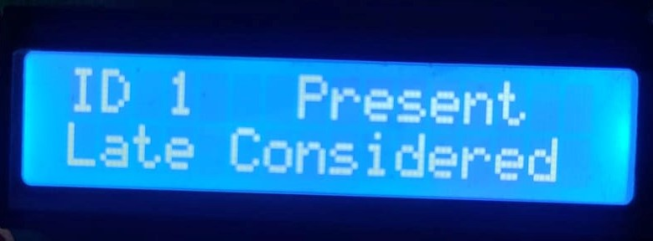 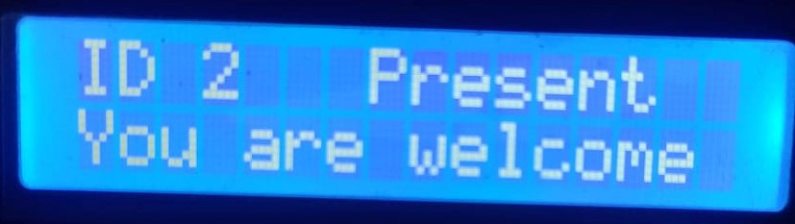

Fig 8(i) – Late Consideration Fig 8(ii) – Within time

**Prototype Design:**

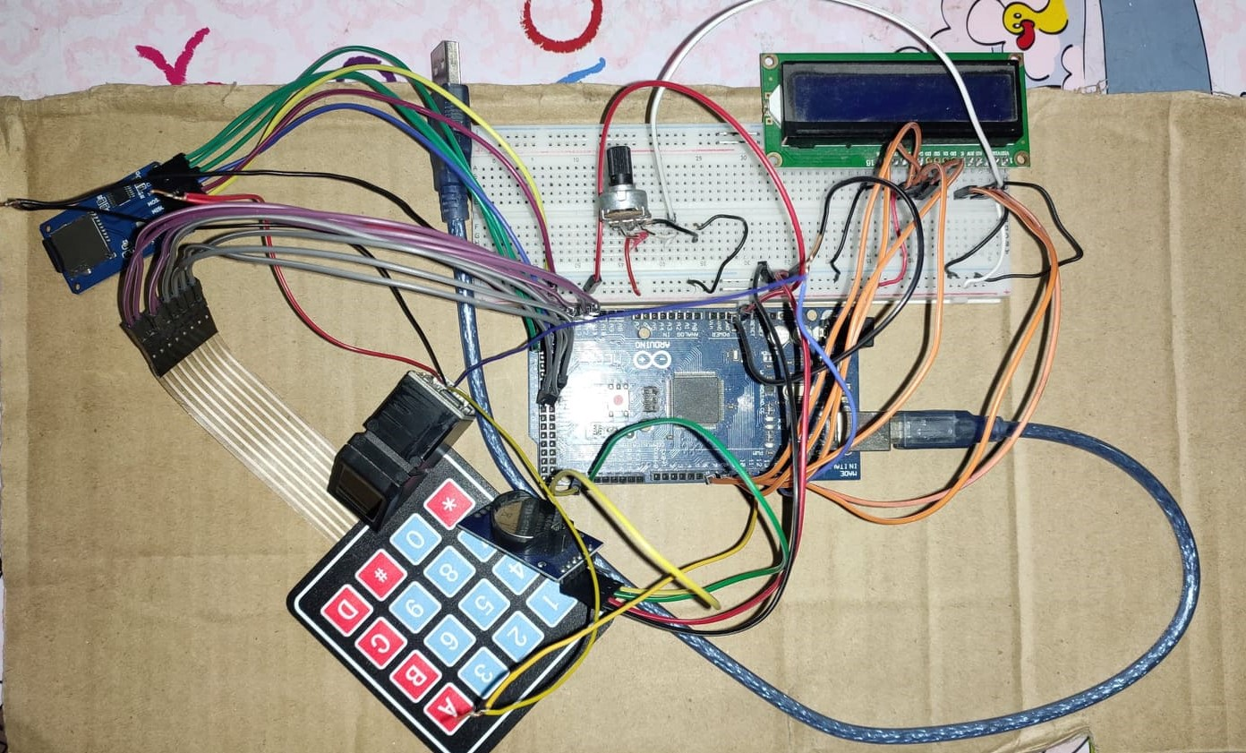

Fig 9: Circuit Design of Fingerprint Based Biometric Attendance System

**Result Analysis:**

Our proposed system has been tested for a class of 30 students and was found to work without any errors. We have tested with 15 classes. Figure 10(i) shows how many students are present in a class and figure 10(ii) shows precentage of total number of present classes against an id.

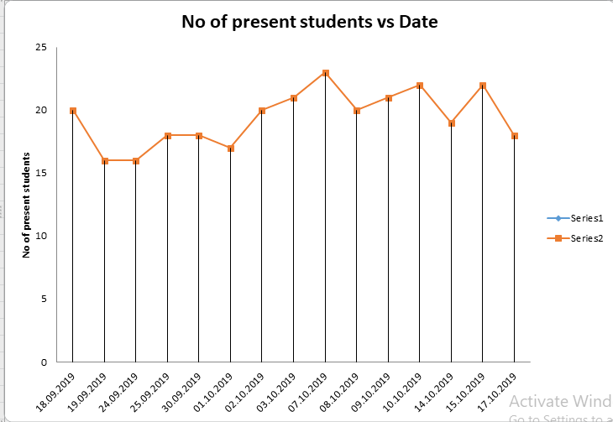 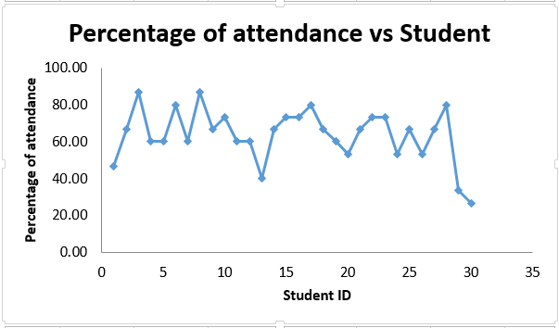Fig 10(i):Attendance of total students in a class Fig 10(ii):Attendance of individual student in total classes

All the students were properly identified and therefore their attendance record was updated. We can see that percentage of attendance of some students are below 60%.

**Discussion:**

The system is very helpful to eliminate duplicate or fake attendance entries and errors in time. But to implement the system, we had to face some obstacles. For example, we faced loose connection several times with fingerprint module. And “module not found” problem was arised. To solve it every time, we had to tighten the wirings. The main problem was created by the SD Card Module. After every few minutes, it was loosing connection. Even sometimes in the middle of the process, it was loosing connection. We overcame it by checking and tightening the wirings several times. Every time any errors were occurring, we had to restart the procedure. In spite of all the obstacles, a successful system has been created which will be very helpful for our education system.

**Conclusion:**

An applicable attendance system has been designed for educational organizations in this project. If this project can be designed practically, it would help to reduce many issues such as denying the possibilities of cheating in recording the attendance, help to ease the lecturers to keep track of student’s attendance, there will be no anonymous fingerprint which is able to tamper with the recorded data, and it saves time in taking attendance instead of queuing in a line.

portable attendance system which is based on fingerprint

identification. The system helped to reduce many issues such

as, denying the possibilities of cheating in recording the

attendance, helps to ease the lecturers to keep track of

students’ attendance, the encryption technique adds more

security so there will be no anonymous fingerprint which is

able to tamper with the recorded data, and the portability

saves time in taking attendance instead of queuing in a line.

Future works will include battery life indicator and

additional security enhancement and backup system.

This paper has presented the design and development of

portable attendance system which is based on fingerprint

identification. The system helped to reduce many issues such

as, denying the possibilities of cheating in recording the

attendance, helps to ease the lecturers to keep track of

students’ attendance, the encryption technique adds more

security so there will be no anonymous fingerprint which is

able to tamper with the recorded data, and the portability

saves time in taking attendance instead of queuing in a line.

Future works will include battery life indicator and

additional security enhancement and backup system.

This paper has presented the design and development of

portable attendance system which is based on fingerprint

identification. The system helped to reduce many issues such

as, denying the possibilities of cheating in recording the

attendance, helps to ease the lecturers to keep track of

students’ attendance, the encryption technique adds more

security so there will be no anonymous fingerprint which is

able to tamper with the recorded data, and the portability

saves time in taking attendance instead of queuing in a line.

Future works will include battery life indicator and

additional security enhancement and backup system.

**Limitations:**

This biometric device does not always read an individuals fingerprint accurately. If a student does not place his/her correct finger in the right spot, the fingerprint module may not read the student’s identification properly. In case of any physical changes in finger, our system fails to identify the student accurately. Sometimes the system doesn’t work properly because of loose connections.

**Future Plan:**

Try to overcome all limitations and make some improvements in this project to make it more realistic such as the project can be extended to store the attendance details in database on the server and a website will be hosted on the server so that attendance details along with academic details will be visible to a student. It will be designed for multiple courses. The system may also be designed with IOT so that the authority can keep the parents informed about the student’s performance via SMS alerts.

**References:**

1. <https://www.researchgate.net/publication/282749509_Design_and_development_of_portable_classroom_attendance_system_based_on_Arduino_and_fingerprint_biometric>
2. https://bestengineeringprojects.com/fingerprint-attendance-system-using-arduino/
3. <https://randomnerdtutorials.com/guide-to-sd-card-module-with-arduino/>
4. <https://www.instructables.com/id/Real-time-clock-using-DS3231-EASY/>
5. <https://www.maxphi.com/4x4-membrane-keypad-arduino-interfacing-tutorial>
6. <https://electronicsforu.com/resources/learn-electronics/16x2-lcd-pinout-diagram>
7. https://ijret.org/volumes/2015v04/i02/IJRET20150402038.pdf